**Translink Safety Bus**

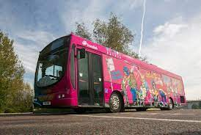

Kevin talked to us about travelling safely on a bus.

Tyler

Don’t yell or shout. Thomas

Obey the bus driver. Eoin

Fasten your seatbelt. Jonah

Sit quickly and stay seated. Tulisa

Only ring the bell once. Johnny

Walk off the bus in turn. Jonah

Wait to the bus moves before crossing the road. Eli

Line up and don’t push or shove. Caedan