PRIMARY
CHRISTMAS DINNER
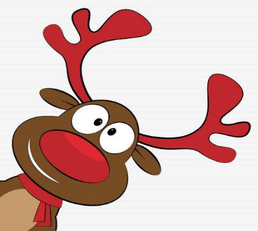
Menu

ROAST TURKEY, STUFFING, COCKTAIL SAUSAGES, PEAS, CARROTS,
MASHED & ROAST POTATOES & GRAVY

DESSERT OF THE DAY

ORANGE JUICE

