**Moving to Secondary School!**



Hi there, my name is the Fabulous Big Blue Text Book but you can call me Textie for short. I’m here to work through this booklet with you to see if we can get you ready for moving on to secondary school. First I’m going to need to know your name

**Name: _______________________________**

**School: _______________________________**

**Age: __________________________________**



Wow, Year 7! You made it! Now you are going to be thinking about moving on to a new school. Let’s see what you know about where you are going.

**A Big New Adventure!**

The name of my new school is:

The address is:



The school telephone number is:

The name of my new Principal is:

Do you know what a Head of Year is? Yes No

Can you name your Head of Year?



Knowledge is Power, my friend! Get to know as much as you can about your new school and it will make the change that much easier. Most schools now have a website and you can it (with your parent’s permission) to get all the information you can!





You need to think about how you are going to get there. Your new school may have a different starting time and the last thing you want to be doing is rushing on the first day. Give yourself plenty of time and plan ahead.

**How to get to School!**

What time does school start?

Yes No

Are you going to walk to school?

Do you know the way?

Will you have a friend to walk with?

Yes No

Will you ride your bike to school?

Do you need special permission?

Yes No

Where will you put your bike when you get to school?

Yes No

Do you have a bike lock?

Yes No

Will you be brought in a car?

Who will drive you?

Yes No

Will you get a lift back home too?

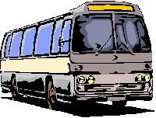Will you catch the bus to school?

Yes No

Where is the bus stop?

What is the number of the bus?

How much bus fare will you need?

Yes No

C:\Users\David\AppData\Local\Microsoft\Windows\Temporary Internet Files\Content.IE5\ZOUV409U\MC900280589[1].wmfWill you go by train?

What time is your train to school?

What time is the train home?

What fare will you need?

What will happen if you miss your train?

How long does your journey take?

What time do you need to leave the house?

What time does school finish?

What time will you get home?



Train yourself to be organised. You will have to be responsible for getting yourself ready and you will have a lot more subjects, books and classes to think about. Give yourself enough time to get out the door so you won’t be in a rush.



A new school means a lot of changes. Each school has its own uniform and it is important to wear your uniform properly when you start there. Remember everyone else in your year will be in the same position and it is important to get it RIGHT. Don’t worry! Give yourself the best possible start and get things ready the night before.

**School Uniform**

**If there are other children in your class who will be going to the same school then get into pairs to fill in the rest of this page.**

Describe the clothes or uniform of your new school _________________________________________________________________________________________________________________________________________________________________________________________________________________________________________________________________________________________________________________

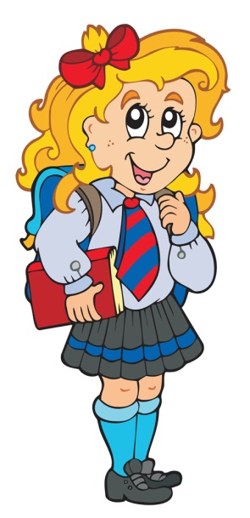

You’ll also need your P.E. kit and equipment. Try to think of some of the things you may need

5 _______________________

6 _______________________

7 _______________________

8_______________________

1 _______________________

2 _______________________

3 _______________________

4_______________________



**Other things you may need**



When starting school there may be a number of things you need to carry in your bag. Having the right tools for the job is always a good idea. It will be useful to practise packing your bag before the new term begins, making sure everything fits.

**Circle the objects below you think you will need and you can draw in any that are missing**.

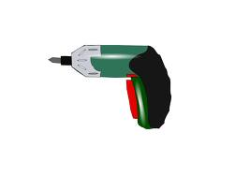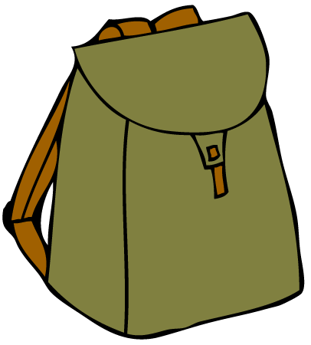



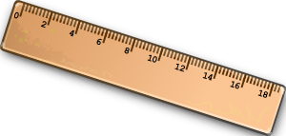





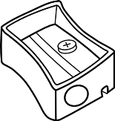



**When you go to your new school some of the subjects you have been learning will be studied in more detail. There will be laboratories for science and workshops for craft design and technology. You will learn about yourself and about working with others. You may need to bring special clothes or equipment for these subjects. Make a list of some of the subjects that you might do in the first year which will need special equipment.**

|  |  |
| --- | --- |
| **SUBJECT** | **I WILL NEED** |
|  |  |
|  |  |
|  |  |
|  |  |
|  |  |
|  |  |
|  |  |



This may seem like an awful lot to remember and cope with but the rest of the Year 8s will have the same to deal with. All the older pupils had to go through the same experience. The pupils before you managed and so will you! Remember the teachers will be there to help and guide you through.

**A Day at Your New School!**



Your new school will be different. Each school has its own way of running things. Although you may already know many of them, let’s try to think about some of the things that secondary schools have in common.

Boys and girls of your age will be coming from different Primary Schools to join you at your new school. Your day will be split into periods and you will be given a timetable telling you what subject you are to study and which of the many teachers will take you for it. You will have to move about the school, going to the room of the teacher who is to teach you for that period.

C:\Users\David\AppData\Local\Microsoft\Windows\Temporary Internet Files\Content.IE5\839C4AD3\MC900415574[1].wmf



Your timetable is an essential tool and it is important that you carry it with you all the time. It lets you know where you are going and what you need for the rest of the week.

Below you will see an example of a 2 week timetable

Week 1

|  |  |  |  |  |  |
| --- | --- | --- | --- | --- | --- |
|  | **Monday** | **Tuesday** | **Wednesday** | **Thursday** | **Friday** |
| 9:00 | English | Maths | Science | HE | Maths |
| 10:00 | B | R | E | A | K |
| 10:30 | Maths | Science | English | IT | Science |
| 11:30 | PE | English | RE | Science | IT |
| 12:30 | L | U | N | C | H |
| 1:30 | HE | Technology | Games | Maths | RE |
| 2:30 | Music | Technology | Games | PE | English |
| 3:30 | Home | Home | Home | Home | Home |

Week 2

|  |  |  |  |  |  |
| --- | --- | --- | --- | --- | --- |
|  | **Monday** | **Tuesday** | **Wednesday** | **Thursday** | **Friday** |
| 9:00 | Maths | Science | Technology | Maths | Science |
| 10:00 | B | R | E | A | K |
| 10:30 | French | English | Science | English | Maths |
| 11:30 | Science | RE | IT | English | French |
| 12:30 | L | U | N | C | H |
| 1:30 | Technology | IT | Maths | Games | English |
| 2:30 | Technology | PE | RE | Games | Assembly |
| 3:30 | Home | Home | Home | Home | Home |



**More Fun Facts!**

At your new school you will have more freedom and you won’t be tied to one room and one teacher. When you move from period to period you may not be with the same pupils you were with in the previous class. Here are some things for you to consider to help you along.

You will need to find out from your school how and when they have their registration. Be aware that registration may be recorded twice a day and you don’t want to be marked absent if you are present.

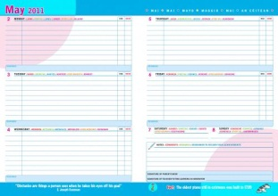You are likely to be split into different classes. Although there may be a teacher responsible for your class, it is likely the person you will go to for help, or to discuss a problem with, will be the **Head of Year**. This teacher will be responsible for all the Year 8s.

You will have more homeworks as each teacher can set homework for their subject. A **Homework Diary** will be essential for keeping track of what you have to do and when it needs handing in. Not all homeworks are for the next day but you need to keep on top of your work or it will build up.

To help the school may provide you with a locker. You will be responsible for looking after it and make sure, if you are leaving books there, that you have enough time to get what you need between classes.

C:\Users\David\AppData\Local\Microsoft\Windows\Temporary Internet Files\Content.IE5\PG196IOK\MC900089004[1].wmfYou will be meeting a lot of new people. Try and be as friendly as you can. Remember that listening can be as important as talking. A smile doesn’t hurt. It will take time to remember names but make the effort. Take your time in getting to know people. If you feel unsure or uncomfortable with the actions of others, or you know their behaviour is wrong, then maybe they are not the type of people you want as friends. Do what you know is right and be strong. In time you will make the kind of friends, who will hopefully will encourage you to do your best.

**Mistakes Can Happen!**



I have news for you. Nobody gets it right 110% of the time. If you do forget something it’s not the end of the world. It can happen to the best of us. If you do forget something it is good to explain and apologise to the teacher. They may be able to arrange for you to share or have a spare one you can use.

**Pretend that you have forgotten something. Practice explaining to the teacher with the person beside you or with your teacher and then it will be easier if it does happen.**

**FOR EXAMPLE - “I am sorry Sir/Miss. I’m not used to my timetable yet and I have forgotten to bring the right book. I will remember it for the next lesson.”**

Mistakes can happen sometimes because we did not understand exactly what the teacher meant. Some things may be different from what you are used to and if you pretend that you understand when you don’t, then the teacher will not know that you need help. There is no shame or weakness in admitting you did not understand the first time. It’s likely others will be the same and relieved you have spoken up. The teacher will always prefer that you understand properly before moving on.



Invent a situation where you have not understood exactly what the teacher meant and discuss this with a partner. Take turns practicing explaining to the teacher what has happened.

FOR EXAMPLE - “I am sorry Sir/Miss. I have been listening but I didn’t quite understand what you meant when you explained what we had to do forhomework. Please could you tell me again so I can be sure I’ve written it down correctly?”

**Following the Rules**



Your new school will have rules just as your old one did. Sometimes we agree with the rules and sometimes we don’t but we know that if we break a rule we will be punished.

**Rules are made for different reasons**;

* + TO PROTECT US
  + TO PROTECT OTHER PEOPLE
  + TO PROTECT SCHOOL PROPERTY.
  + TO ALLOW THE SCHOOL TO WORK SMOOTHLY.
  + TO PROVIDE THE BEST POSSIBLE EDUCATION FOR EVERY PUPIL.
  + TO MAKE SURE EVERYONE WORKS WITHIN THE SAME STANDARDS.



What rules would you have if you were in charge of a big school full of busy teachers with lots of pupils moving about the school and trying to do their work? On the next page write down five rules which will be easy to understand, easy to obey and will help the school to run smoothly.

1_______________________________________________________

2_______________________________________________________

3_______________________________________________________

4_______________________________________________________

5_______________________________________________________

Which is the most important or best rule in your school?

Can you think of a rule which you feel is silly or unfair? Write it down and discuss it with your teacher.

**Induction Day**



“Induction day” is a complicated name for the day you get to visit the school you will be going to, to meet some of the people and see some of your classes. This will be specifically for pupils starting at the school so it will be different to the open night. Often, most of the older pupils are not there, to give you time to get used to your new school before it is filled with the rest of the pupils.

Now that you have worked right through this booklet you will know the sort of things you need to prepare for going to secondary school. You may have thought of some questions that you would like to ask on the induction day so now is the time to plan to get the most out of the day.

Some schools arrange more than one day. This page has been planned for a one day visit but you can adapt and use it to fit your schools induction.

**When is the Induction?**

**What time do you have to be there?**

**How will you get there?**

**Who will you go with?**

**What do you want to find out?**

**What do you want to see?**

**Back at your own School**



If your new school arranges for you to have a visit before you’ve left Year 7, you can use this section to record how it was for you. Be honest!

Your teacher will discuss the visit with the class and this is your opportunity to ask questions if there was anything that you didn’t understand or felt worried about.

**What did you like about your new school?**

**What did you not like?**

**Was there anything that you didn’t understand or that you still need to find out about?**

Well you’ve made it this far. Hopefully you have thought long and hard about what you need to prepare for changing school. This should make everything go that much smoother. A new school will provide you with lots of new experiences, interesting lessons and new friends to make. There is much to look forward to. Although education is a right in this country you will only get out of school what you are prepared to put in. Work hard and give yourself the best possible start in life. Above all try and enjoy it. I wish you all the best and leave you with one important piece of advice;

**KEEP SMILING**



**Big School Question Sheet**

Name: _______________________ School: ____________________

Are you looking forward to the move to your new school?

Please list up to 5 things you are looking forward to and up to 5 things which you may be a little worried about. This information will help us to help you to “settle in”.

I am looking forward to:

1)__________________________________________________

2)__________________________________________________

3)__________________________________________________

4)__________________________________________________

5)__________________________________________________

I am a little worried about:

1)__________________________________________________

2)__________________________________________________

3)__________________________________________________

4)__________________________________________________

5)__________________________________________________

Here are some examples to help but please use your own if you have them.

Wearing the uniform and games kit

Taking a shower

What if I am late?

Finding my way around

Joining clubs

Making new friends

Learning new subjects

Homework

Meeting others my own age

School rules

Adapted from Roberts, B. (1989)

Moving between classes

Meeting new teachers

Questionnaire to follow up with possibly February

The Big School…Follow up questionnaire

Name

Tutor Group

Date

1) List the things which you really enjoyed so far.

Box

2)List the things which you are still looking forward to.

Box

3)List the things which you are still a little worried about

4)Read each sentence and put ✓ under the face which suits you.

|  |  |  |  |
| --- | --- | --- | --- |
|  | Most of the time ☺ | Sometimes  : | Rarely  ☹ |
| I look forward to going to school when I wake up |  |  |  |
| I am happy when I am in school |  |  |  |
| I enjoy school |  |  |  |
| I enjoy school work |  |  |  |
| I have found my way around |  |  |  |
| I enjoy homework |  |  |  |
| I stick to the school rules I’ve learnt |  |  |  |

|  |  |  |  |
| --- | --- | --- | --- |
| I enjoy P.E. and shower time |  |  |  |
| I enjoy making new friends |  |  |  |
| I like the new subjects |  |  |  |
|  |  |  |  |

What did you think about the day you spent at school in the summer term?

How could the day be improved (e.g. for pupils coming here next year)?

What advice would you give to the pupils who come here next year?

Describe your first day at school (e.g. how you felt before school, during and after lessons, meeting new teachers, meeting new pupils etc.)

**Thank you for your help!**